Preparation List For Nagoya Protocol Analytics Workshop

Software Instructions

We will be using *online accounts* and *software* that you must sign up for and download on to your computers **before** the workshop:

Please follow the information below closely. You will need to install four pieces of software:

1. Tableau Public
2. Gephi 9.2
3. Open Refine
4. R and RStudio

This will take 30 minutes to 1 hour of your time. However, as there will be up to 50 participants it can take up a great deal of time if participants do not follow these instructions *before* the workshop. Please help everyone out.

If you get stuck or something goes wrong do not panic, we can fix problems later on. If you get stuck but have a teenager lying about somewhere they may prove useful in helping you to get unstuck (it is your call).

If you are on a work computer that will not allow you to install software please contact your system admin for help.

1. **Tableau Public**

Sign up for a Tableau Public Account (free) and download the Tableau Public software for your system.

<https://public.tableau.com/s/>

**Make a note of your username and password** and keep it somewhere accessible as you will need it.

Download the software and open it to check it works

1. **Gephi 0.9.2**

Go to <https://gephi.org/users/download/> and choose your operating system.

Please test that Gephi will open as it sometimes needs adjustment to settings.

If you are successful you should see something very like this with **Welcome to Gephi.**

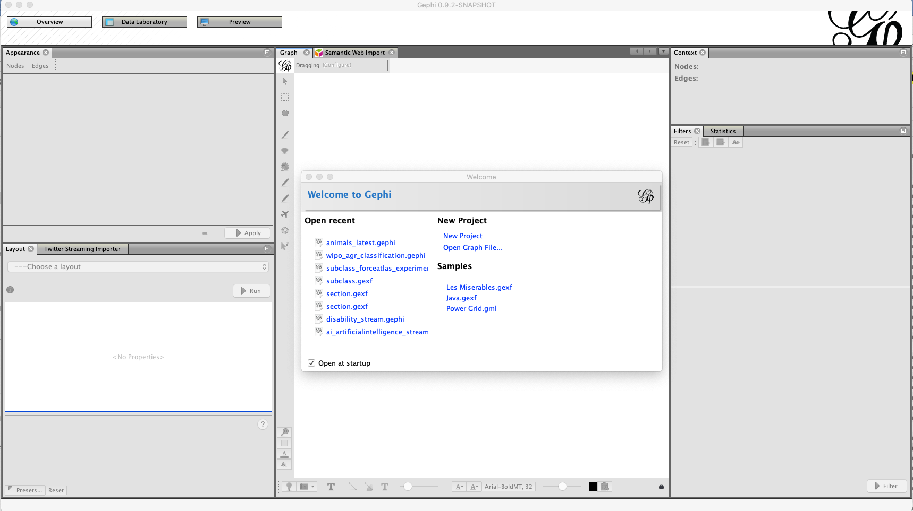

In Samples try clicking on “Les Miserables.gexf”. **Click OK at the prompt** and you should see this.

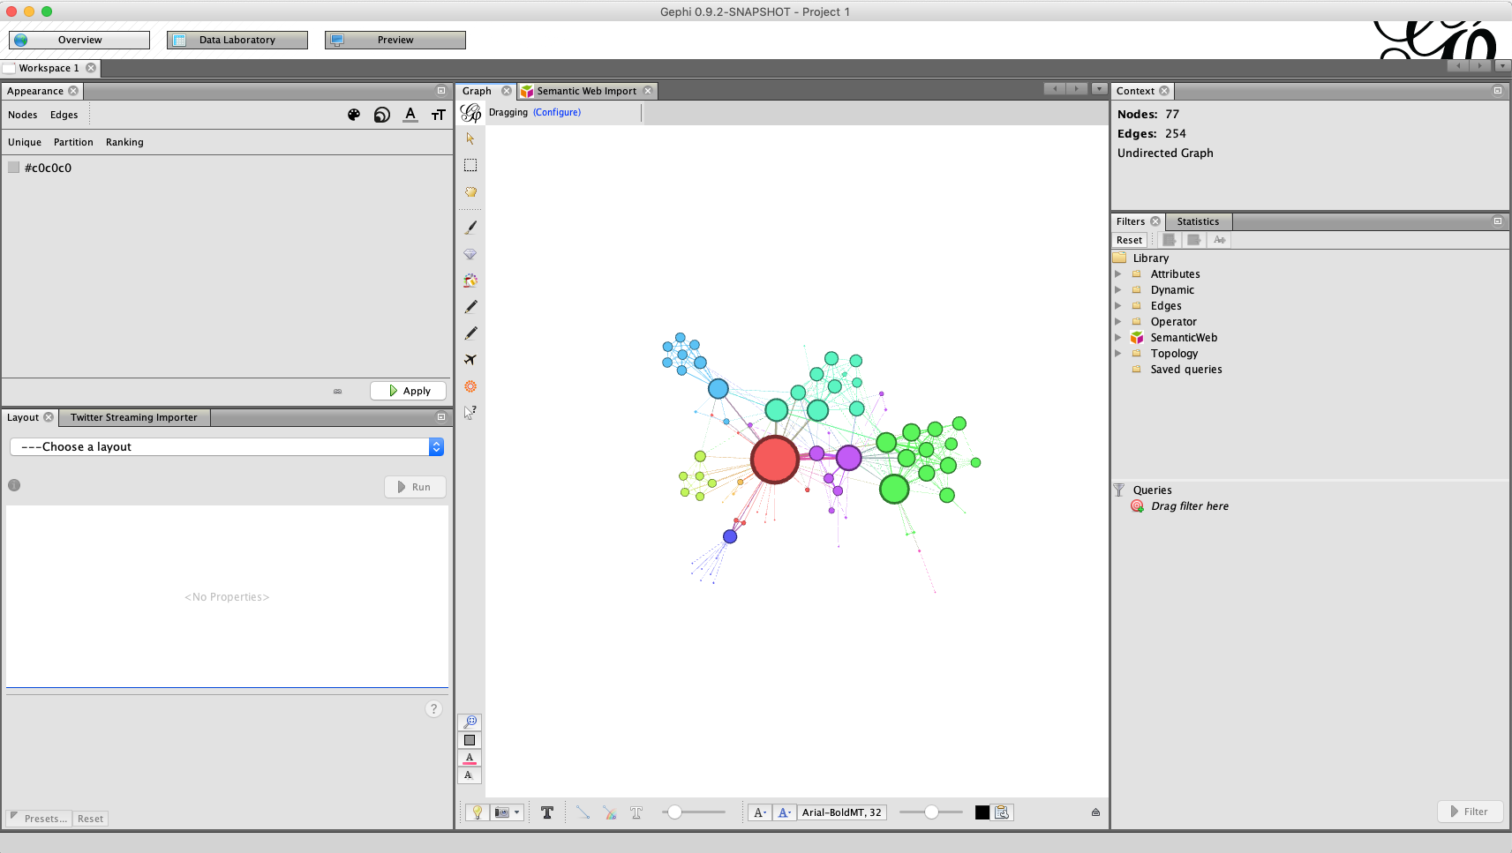

You are good. If you *only see a grey screen in the middle* Gephi does not have the version of Java that it needs. If you are happy to try and fix it yourself follow the instructions from the link at the bottom of this document. If not, then let us know when you arrive at the workshop and one of the techies will try to fix it.

**Next:** When Gephi is open we need to **install some plugins**.

Go to:

Tools > Plugins > Available Plugins

In Available Plugins tick the box next to:

Convert Excel and csv Files to Networks

Then choose install and just keep clicking OK and Continue until you are asked to **restart** (reboot) Gephi.

1. **Open Refine (Data Cleaning Tool)**

Download and install Open Refine (Open Refine 3.2) for your operating system. There are various versions so make sure to *choose 3.2* and ignore anything else

<https://github.com/OpenRefine/OpenRefine/releases/download/2.7/openrefine-win-2.7.zip>

Open Refine/Google Refine works with the Chrome browser (and will not work with Internet Explorer). **Please ensure that Google Chrome browser is installed and set as the pre-defined web browser, so that Open Refine will open. When you start Open Refine you should see this.**

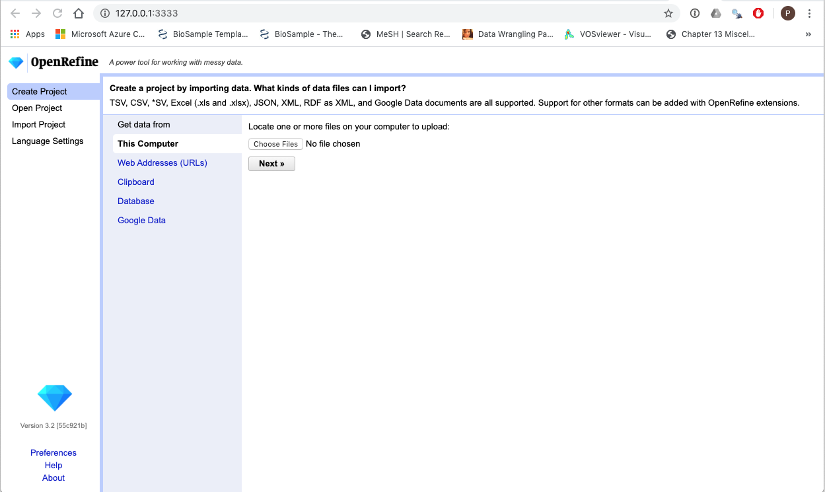

If you do not see this in **Google Chrome close the browser and look up “set google chrome as default browser” on Google.** Look for instructions for your operating system. It is easy.

1. **Install R and RStudio**

This involves three steps but is quick:

**Step 1.** Install the version of R for your system (called base) from here

The link to download R is here <https://cran.rstudio.com/>

Choose Run and follow the instructions.

**Step 2.** Download the **RStudio** for your system from

<https://rstudio.com/products/rstudio/download/>

You Want RStudio Desktop Free (first column) in the image below. Press Download.

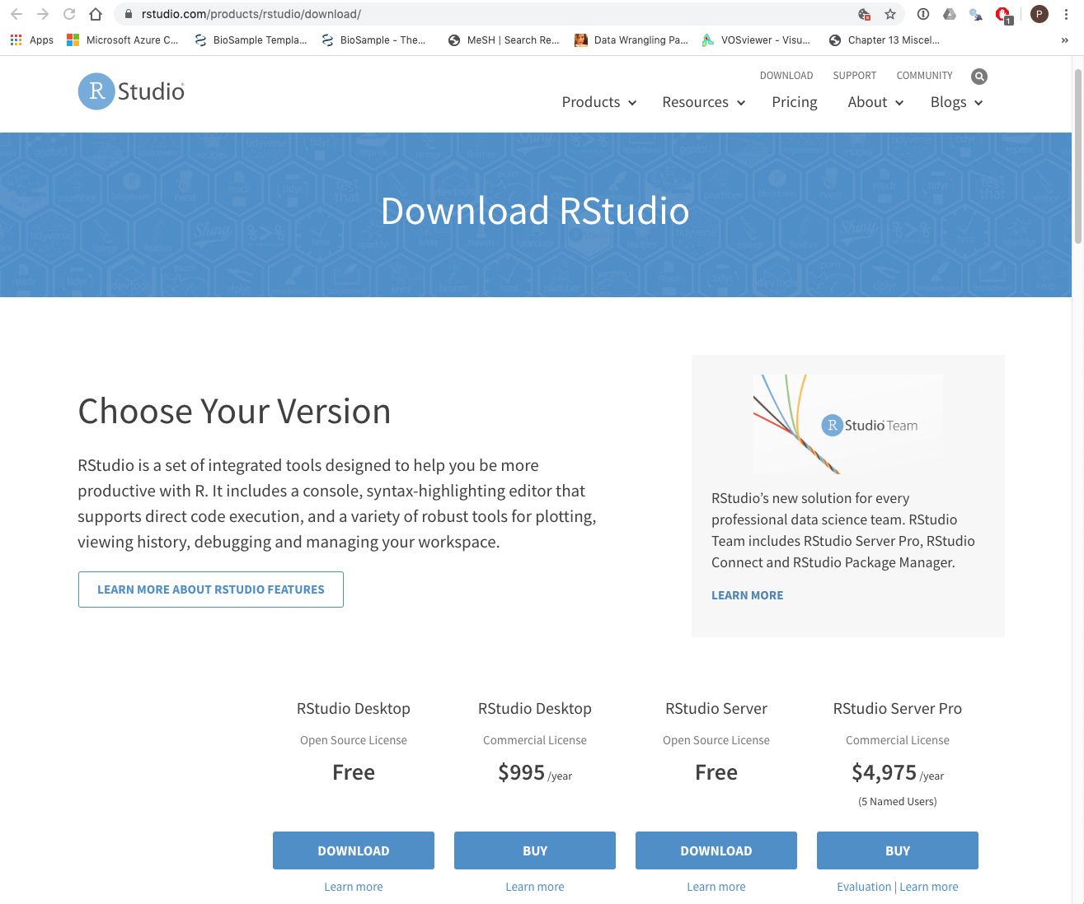

**Step 3.** Open RStudio

At the bottom of the screen you will see a space called Console with a prompt. Type the following in at the prompt or copy it from here: install.packages("tidyverse")

Lots of red lines will flash by for around five minutes. When that has finished please do the same again. This time type or copy and paste the following. If prompts appear asking for updates I suggest pressing no (it just takes longer if you say yes)

install.packages("bookdown")

install.packages("taxize")

install.packages("rentrez")

install.packages("rcrossref")

1. **Fixing a Gephi Installation**

Gephi needs a specific version of Java. This can be difficult to keep track of but it means you normally need Java JDK 1.7. If you are on Windows try the instructions here:

<https://github.com/wipo-analytics/presentations/blob/master/gephi_installation.pdf>

If that doesn’t work or you are on a Mac try the Forum here: <http://forum-gephi.org/>

The good news about this rather annoying problem is that once it is solved it stays solved.